**Analysis plan**

Clinical and molecular epidemiology of carbapenemase-producing Enterobacterales in hospitalized patients in the Cape Town Metropole, South Africa

Authors: Dr. Shantelle Claassen-Weitz and Dr. Clinton Moodley

__________________________________________________________________________________

**Background:**

Inappropriate prescription and administration of antibacterial drugs have resulted in resistant bacteria becoming a primary public health treat [1]. In 2019, sub-Saharan Africa showed the highest antibacterial resistance burden globally [1].

In 2017, the World Health Organization (WHO) identified antibiotic resistant bacteria for which new antibiotics are urgently required [2]. High priority antibiotic resistant bacteria included carbapenem-resistant *Acinetobacter baumannii* and *Pseudomonas aeruginosa*, as well as extended-spectrum beta-lactamase-producing (ESBL-producing) and carbapenem-resistant Enterobacteriaceae [2].

Carbapenem-resistant Enterobacteriaceae (CRE), which pose an exponentially increasing threat for public health globally, emerged from the widespread use of carbapenem as first-line empirical treatment for ESBL-producing Enterobacteriaceae [3]. CREs possess diverse mechanisms of drug resistance, limiting early detection and infection control. CREs are categorized into two subgroups: A) carbapenemase-producing CRE (CP-CRE) and B) non-carbapenemase-producing CRE (non-CP-CRE) [4].

CP-CREs produce a variety of carbapenemases categorized into three Ambler classes. Class A carbapenemases include the plasmid encoded enzyme *Klebsiella pneumoniae* carbapenemase (KPC) which actively hydrolyzes carbapenems, partially inhibited by clavulanic acid [4]. Enterobacteriaceae producing KPCs have acquired multidrug resistance to β-lactams and is considered most prevalent globally. Clinical isolates of KPC-producing *Klebsiella oxytoca*, *Escherichia coli*, *Enterobacter aerogenes*, *Enterobacter cloacae*, *Citrobacter freundii*, *Proteus mirabillis*, *Salmonella enterica* and *Serratia marcescens* have been identified [4]. Class B carbapenemases include metallo-β-lactamases (MBLs) – enzymes which depend on the interaction with zinc ions in the active site of the enzyme [4]. These enzymes have high potential for horizontal transfer and have broad hydrolytic properties that affect most β-lactam antibiotics. MBL families include New Delhi metallo-β-lactamase 1 (NDM-1), Imipenem-resistant Pseudomonas (IMP)-type carbapenemase and Verona integron-encoded metallo-β-lactamases (VIM) [4]. Class D carbapenemases are OXA-48-like (most widespread) including five other variants (OXA-162, OXA-163, OXA-181, OXA-204, OXA-232). These plasmid-mediated enzymes are primarily found in *K. pneumoniae*, *E. coli*, *E. cloacae* and *C. freundii*, and are highly active against penicillins, have intermediate activity against broad-spectrum cephalosporins and have low activity against carbapenems [4].

Other mechanisms of carbapenem resistance, besides carbapenemase production, include the production of other β-lactamases [for example, Type C ampicillinase (AmpC-type)], porin loss and efflux pump overexpression by non-CP-CREs [4]. Enzymes such as AmpC-type β-lactamases do not degrade carbapenems but form a bond with the carbapenem-molecule which prevents it from accessing its target. Alterations of porin synthesis also contribute to blocking penetration of carbapenems into the bacterial cell. Resistance-nodulation-division (RND) efflux pumps function as a multi-drug resistance mechanism in Enterobacteriaceae [4].

CRE has rapidly spread since the detection of the first strain in the 1980, with different carbapenemases predominating different areas globally [5]. KPC-producing Enterobacteriaceae are endemic to the United States, Colombia, Argentina, Italy and Greece, while NDM-1 is the primary carbapenemase in India, Sri Lanka and Pakistan. OXA-48-like enzyme producers are endemic to North Africa, the Middle East, Turkey and Malta.

OXA-48 and variants, followed by NDM, represent the largest proportion of carbapenemases in South Africa, with *K. pneumoniae* reported as the most common isolate [6]. Although the first report of CPE in South Africa was in 2011 [7][8], with remarkable increases in the isolation of suspected CPE observed on a national level, clinical and molecular epidemiology of CPE in both private and public sectors in South Africa remain unknown. Neither genotyping methods nor whole-genome sequencing (WGS) have been implemented to confirm suspected CPE nor determine transmission clusters of resistant determinants.

**Aims and objectives**

This multidisciplinary, multi-centered, prospective laboratory-based cohort study aims at integrating clinical and molecular epidemiology and determining transmission patterns of CREs among in-patients in both private and public sectors in the Cape Town Metropole, South Africa. This to enable a better understanding of the risk factors, clinical outcomes, and transmission patterns of CREs among in-patients in the Cape Town Metropole. The objective is to inform evidence-based regional patient management, antimicrobial stewardship (AMS) and infection prevention and control (IPC) strategies and interventions.

**Methodology**

*Patient selection*

Patients will be identified prospectively over a 12-month period, based on phenotypic culture results. Public and academic hospitals are served by a single referral laboratory of the National Health Laboratory Service associated with the University of Cape Town. PathCare, Lancet, and Ampath laboratories in Cape town serve all the private hospitals through centralized referral laboratories.

Inpatients with CRE from clinical cultures, defined as “any Enterobacterales” with phenotypic resistance to any carbapenem, will be recruited from daily microbiology laboratory reports in referral laboratories. Any patient from whom a suspected CRE is isolated will be eligible.

*Data extraction*

Hospital-level patient-days (denominator data) will be obtained from participating institutions. Metadata (including the species identity of the Enterobacterales, the types of specimens, and their enzyme genotypes) will be recorded. Once confirmed cases have been identified, subject to informed consent, a questionnaire will be administered regarding known risk factors for CPE colonisation and infection and will also include information regarding HIV status. Retrospective data will be obtained from record review. If the patient is less than 18 years old, informed consent will be sought from an accompanying parent or guardian.

*Risk assessment questionnaire*

The following information will be sought from the patient and from the medical records

|  |
| --- |
| **Demographic variables** |
| Age, sex, ethnicity |
| Housing type |
| HIV status (if positive viral loads and CD4 count) |
| **Exposure variables** |
| *Travel history*: travelled and stayed for at least 3 days outside South Africa in the last year; number of places visited; countries visited; duration of stay in each country; contact with healthcare services at the place of visit |
| *Hospitalisation history\**: hospitalised during preceding one year; number of admissions; place of admission (name and location of institution); duration of admission (days).  * Includes out-patient visit at haematology-oncology units and renal dialysis units |
| *Surgeries*: surgery in preceding one year; number of surgeries, types of surgeries; date of surgeries |
| *Multi-drug resistant organisms* (MDRO) in the past one year: Methicillin-resistant *Staphylococcus aureus* (MRSA), Vancomycin-resistant *Enterococci* (VRE), carbapenem-resistant enterobacterales (CRE), carbapenem-resistant *Acinetobacter baumannii* (CR-AB), carbapenem-resistant *Pseudomonas aeruginosa* (CR-PA) |
| *Time at risk*: days from admission to isolation of CRE |
| *Place of identification of CRE*: Inpatient services (general ward); inpatient services (ICU); outpatient services |
| *Devices during time at risk* with date of insertion: indwelling urinary catheter (IDC); central venous line (CVL); nasogastric tube (NGT) |
| Antibiotic exposure in the preceding 30 days (name, start date, and stop date):  *Carbapenems*: meropenem, imipenem, ertapenem, doripenem  *Cephalosporins*: ceftriaxone, cefepime, ceftazidime  *Extended spectrum penicillins*: piperacillin-tazobactam, amoxicillin-clavulanate  *Fluoroquinolones*: ciprofloxacin, levofloxacin, moxifloxacin  *Aminoglycosides*: gentamycin. Amikacin  *Macrolides*: erythromycin, azithromycin, clarithromycin  *Other antibiotics:* vancomycin, tigecycline, colistin, co-trimoxazole, linezolid, daptomycin, teicoplanin, fosfomycin |
| *Comorbidities:* tuberculosis, cardiovascular disease; cerebrovascular disease; dementia; chronic pulmonary diseases; chronic liver diseases; diabetes mellitis; chronic kidney diseases; solid tumours; haematological malignancies (leukaemias and lymphomas) |
| *Severity Score:* age-adjusted Charlson comorbidity index score |
| **Outcome variables** |
| Length of hospitalisation and in-hospital mortality |
| *30-days follow-up status*: alive without re-admission, alive with re-admission, died |

*Bacterial isolates and whole genome sequencing*

Clinical isolates of Enterobacterales were cultured from blood, tracheal aspirates or bronchi-alveolar lavage, urine in catheterized patients, tissue, pus and fluid from sterile sites including complicated intra-abdominal infections. Isolates were included if non-susceptible to any carbapenem (ertapenem MIC </= to 0.5 mg/L; meropenem, imipenem MICs </=1 mg/L) by routine phenotypic susceptibility tests (Vitek and/or E-tests). Screening cultures (gastro-intestinal tract colonization) were excluded.

All phenotypically confirmed carbapenem non-susceptible bacterial isolates collected during the study period were submitted for confirmatory PCR, to identify the presence of a carbapenemase (CPE) or otherwise non-carbapenemase-producing carbapenem-resistant Enterobacterales (NCPE).

Phenotypically confirmed carbapenem non-susceptible bacterial isolates submitted for whole genome sequencing (WGS) were stored at -80ᵒC until cultivated overnight at 35ᵒC using 2% blood agar plates. Pure subcultures were processed for nucleic acid using the Quick-DNA Fungal/Bacterial Miniprep Kit (catalogue no. D6005, Zymo Research Corp., Irvine, CA, USA). The NanoDrop® ND-1000 Spectrophotometer was used to assess nucleic acid quantity and quality. A maximum of 400 ng of nucleic acid per well was loaded onto a 1.5% agarose gel and electrophoresis performed at 100 Volts for 1 hour on the GloMax®-Multi Detection System (Promega Corporation, Madison, WI, USA) to confirm nucleic acid quality. Each nucleic acid extract was diluted to 300 ng in a final volume of 30 μl nuclease free water (add manufacturer details).

Library preparation was performed using the Nextera™ DNA Flex Library Preparation Kit (catalogue no. 20018704, Illumina, Inc., San Diego, CA, USA) together with Nextera™ DNA CD Indexes. Library concentrations were confirmed using the Qubit® Fluorometer (Invitrogen, Life Technologies, CA, USA) and Qubit™ dsDNA HS Assay Kit (catalogue no. Q33230, Invitrogen, Life Technologies, CA, USA). Fragment sizes and concentrations were measured for randomly selected libraries using D1000 ScreenTape Assay for TapeStation Systems (Agilent Technologies, CA, USA). Individual libraries were pooled at 50 ng each.

The pooled library was quantified using the Qubit® Fluorometer and Qubit™ dsDNA HS Assay Kit and diluted to 4 nM in a final volume of 20 μl using resuspension buffer (catalogue no. 20018704, Illumina, Inc., San Diego, CA, USA). Two pooled libraries, representing 11 and 12 isolates respectively, were sequenced using the MiSeq Reagent Kit v2 (300 cycles) (catalogue no. MS-102-2002, Illumina, Inc., San Diego, CA, USA). Loading concentrations of the pooled libraries were calculated at 12 pM and 9 pM, respectively. Each pooled library contained the PhiX internal sequencing control spiked at 2% and generated 2 x 150 bp paired-end reads on the Illumina® MiSeq™ platform.

*List of isolates sequenced*

|  |  |  |  |  |  |  |  |
| --- | --- | --- | --- | --- | --- | --- | --- |
| Sample_ID | Organism ID | Hospital | Run | I7_Index_ID | index | I5_Index_ID | index2 |
| KLEB_CRE_GSH_0001 | Klebsiella pneumoniae subsp pneumoniae | GSH | Pool A | H705 | GGACTCCT | H503 | TATCCTCT |
| ECOL_CRE_GSH_0002 | Escherichia coli | GSH | Pool A | H706 | TAGGCATG | H503 | TATCCTCT |
| KLEB_CRE_GSH_0003 | Klebsiella pneumoniae subsp pneumoniae | GSH | Pool A | H707 | CTCTCTAC | H503 | TATCCTCT |
| KLEB_CRE_GSH_0007 | Klebsiella pneumoniae subsp pneumoniae | GSH | Pool A | H710 | CGAGGCTG | H503 | TATCCTCT |
| KLEB_CRE_GSH_0008 | Klebsiella pneumoniae subsp pneumoniae | GSH | Pool A | H711 | AAGAGGCA | H503 | TATCCTCT |
| KLEB_CRE_GSH_0010 | Klebsiella pneumoniae subsp pneumoniae | GSH | Pool A | H714 | GCTCATGA | H503 | TATCCTCT |
| KLEB_CRE_GSH_0011 | Klebsiella pneumoniae subsp pneumoniae | GSH | Pool A | H705 | GGACTCCT | H505 | GTAAGGAG |
| KLEB_CRE_GSH_0013 | Klebsiella pneumoniae subsp pneumoniae | GSH | Pool A | H706 | TAGGCATG | H505 | GTAAGGAG |
| KLEB_CRE_GSH_0014 | Klebsiella pneumoniae subsp pneumoniae | GSH | Pool A | H707 | CTCTCTAC | H505 | GTAAGGAG |
| KLEB_CRE_GSH_0015 | Klebsiella pneumoniae subsp pneumoniae | GSH | Pool A | H710 | CGAGGCTG | H505 | GTAAGGAG |
| KLEB_CRE_GSH_0016 | Klebsiella pneumoniae subsp pneumoniae | GSH | Pool A | H711 | AAGAGGCA | H505 | GTAAGGAG |
| KLEB_CRE_GSH_0018 | Klebsiella pneumoniae subsp pneumoniae | GSH | Pool B | H714 | GCTCATGA | H505 | GTAAGGAG |
| KLEB_CRE_GSH_0019 | Klebsiella pneumoniae subsp pneumoniae | GSH | Pool B | H705 | GGACTCCT | H506 | ACTGCATA |
| SERR_CRE_GSH_0021 | Serratia marcescens | GSH | Pool B | H706 | TAGGCATG | H506 | ACTGCATA |
| KLEB_CRE_GSH_0022 | Klebsiella pneumoniae subsp pneumoniae | GSH | Pool B | H707 | CTCTCTAC | H506 | ACTGCATA |
| KLEB_CRE_GSH_0023 | Klebsiella pneumoniae subsp pneumoniae | GSH | Pool B | H710 | CGAGGCTG | H506 | ACTGCATA |
| SERR_CRE_RXH_0002 | Serratia marcescens | RXH | Pool B | H711 | AAGAGGCA | H506 | ACTGCATA |
| KLEB_CRE_RXH_0003 | Klebsiella pneumoniae subsp pneumoniae | RXH | Pool B | H714 | GCTCATGA | H506 | ACTGCATA |
| SERR_CRE_RXH_0005 | Serratia marcescens | RXH | Pool B | H705 | GGACTCCT | H517 | GCGTAAGA |
| ECLO_CRE_RXH_0006 | Enterobacter cloacae | RXH | Pool B | H706 | TAGGCATG | H517 | GCGTAAGA |
| KLEB_CRE_RXH_0008 | Klebsiella pneumoniae subsp pneumoniae | RXH | Pool B | H707 | CTCTCTAC | H517 | GCGTAAGA |
| KLEB_CRE_RXH_0009 | Klebsiella pneumoniae subsp pneumoniae | RXH | Pool B | H710 | CGAGGCTG | H517 | GCGTAAGA |
| KLEB_CRE_TBH_0008 | Klebsiella pneumoniae subsp pneumoniae | TBH | Pool B | H711 | AAGAGGCA | H517 | GCGTAAGA |

**Sequence data location:**

All raw data is stored on the med micro server ATHENA. There were 2 runs, Pool A and B.

/MedMicro/Clinton/CRE Pfizer Feb 2022/CRE study_1A_results_17022022

/MedMicro/Clinton/CRE Pfizer Feb 2022/CRE study_1B_results_21022022

*Bioinformatics*

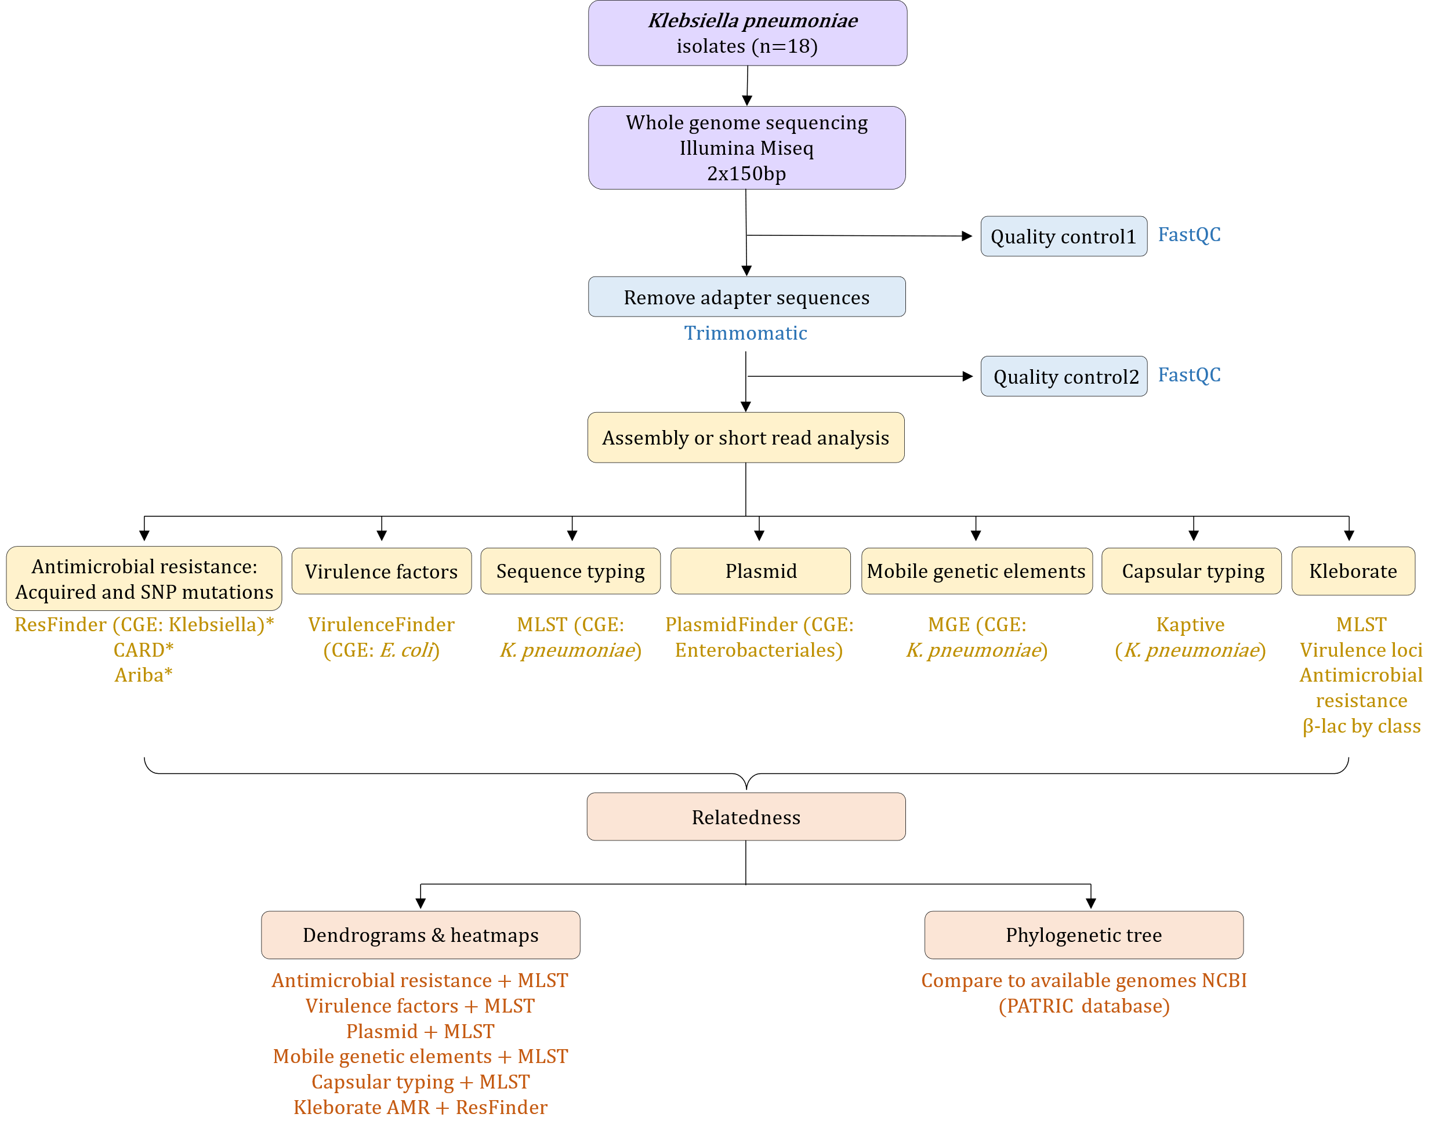

Figure 1. Bioinformatics analysis workflow.

*Please refer to review comparing AMR databases: Galhano et al. 2021 (Microorganisms 2021, 9, 923. <https://doi.org/10.3390/microorganisms9050923>); Boolchandani et al. 2019 (Nat Rev Genet. 2019 June ; 20(6): 356–370. doi:10.1038/s41576-019-0108-4.)

*Reference genomes:*

*Klebsiella pneumoniae* – strain HS11286 (GenBank accession no. CP003200.1) (n=18); *Serratia marcescens* – strain KS10 (GenBank accession no. CP027798.1) (n=3); *Escherichia coli* – strain ATCC 25922 (GenBank accession no. ATCC 25922) (n=1); and *Enterobacter cloacae* – strain ATCC 13047 (GenBank accession no. NC_014121.1) (n=1).

*Sub analysis: Potentially compare results to previous publications:*

* Comparison on mobilome, resistome, methylome, virulome and phylogeography of Carbapenem-resistant *K. pneumoniae* (CRKP) collected in Pretoria (2018) (Kopotso et al 2020: DOI 10.1099/mgen.0.000474) and Cape Town (2021).
* Pathogenomics and Evolutionary Epidemiology of Multi-Drug Resistant Clinical Klebsiella pneumoniae Isolated from Pretoria, South Africa (Mbelle et al 2020: DOI 10.1038/s41598-020-58012-8).
* Klebsiella pneumoniae ST307 with blaOXA-181, South Africa, 2014–2016 (Lowe et al 2019: DOI: https://doi.org/10.3201/eid2504.181482)

**References:**

1. Antimicrobial Resistance Collaborators. Global burden of bacterial antimicrobial resistance in 2019: a systematic analysis. Lancet. 2022;399:629–55.

2. Organization WH. WHO Priority Pathogens List for R&D of New Antibiotics. 2017. https://www.who.int/news/item/27-02-2017-who-publishes-list-of-bacteria-for-which-new-antibiotics-are-urgently-needed.

3. Sheu CC, Lin SY, Chang YT, Lee CY, Chen YH, Hsueh PR. Management of infections caused by extended-spectrum β–lactamase-producing Enterobacteriaceae: current evidence and future prospects. Expert Rev Anti Infect Ther. 2018;16:205–18. doi:10.1080/14787210.2018.1436966.

4. Suay-Garcia B, Perez-Gracia M. Present and future of Carbapenem-resistant Enterobacteriaceae (CRE) infections. Antibiotics. 2019;8:1–16.

5. Brink AJ. Epidemiology of carbapenem-resistant Gram-negative infections globally. Curr Opin Infect Dis. 2019;32:609–16.

6. Singh-Moodley A. Phenotypic and genotypic correlation of carbapenememase-producing Enterobacteriaceae and problems experienced in routine screening. South African Med J. 2018;108:495–501.

7. Brink A, Coetzee J, Clay C, Sithole S, Richards G, Poirel L, et al. Emergence of New Delhi Metallo-Beta-Lactamase (NDM-1) and Klebsiella pneumoniae Carbapenemase ( KPC-2 ) in South Africa. J Clin Microbiol. 2012;50:525–7.

8. Brink AJ, Coetzee J, Corcoran C, Clay CG, Hari-makkan D, Jacobson RK. Emergence of OXA-48 and OXA-181 Carbapenemases among Enterobacteriaceae in South Africa and Evidence of In Vivo Selection of Colistin Resistance as a Consequence of Selective Decontamination. J Clin Microbiol. 2013;51:369–72.